MINDROOM

INNOVATION

25/02/2025

Version: 1.0

Author: Andres Velez

Assessment 1.1

Contents

Executive summary 3

Group members 3

Whatsapp 3

Why it was selected 3

Benefits 3

Features 3

Microsoft Teams 3

Why it was selected 3

Benefits 3

Features 3

Executive summary

The technologies that we selected was Whatsapp and Microsft Teams.

Group members

Andres Velez - [andhyvlz03@gmail.com](mailto:andhyvlz03@gmail.com)

Katherine Vidal - [wms.katherinevidal@gmail.com](mailto:wms.katherinevidal@gmail.com)

Momoka Niitsuma - [momokan726@gmail.com](mailto:momokan726@gmail.com)

Joao Pretto Baumgarten - [joaoprettobaumgarten@gmail.com](mailto:joaoprettobaumgarten@gmail.com)

Illyandra Costain - [illyandrac@gmail.com](mailto:illyandrac@gmail.com)

Whatsapp

Why it was selected

We selected WhatsApp as our team communication tool because it is already familiar to all team members, eliminating any learning curve and allowing us to start using it immediately without setup.

Messages are sent and received in real time, which is highly convenient since our team members have different lifestyles and schedules.

This enables us to stay connected and communicate effectively without needing to coordinate meeting times.

Additionally, WhatsApp’s chat history feature helps minimize miscommunication by allowing us to review past messages. The notification feature also ensures that important messages are not missed, making it a reliable and efficient tool for our team communication.

Benefits

Whatsapp, as the most popular messaging app, has a lot of benefits. Some of those benefits are free messages and calls using Wi-Fi or mobile data and a global reach, which allow people to be connected with anyone, anywhere, at anytime. This app is also useful to share multimedia like photos, videos or documents and to communicate with a group of persons at the same time by creating a group chat. It will not be a real-time communication because people can reply your messages instantly or when they are available, but its end-to-end encryption ensure your messages are private and secure.

Features

* Messages (texts, voice messages)
* Voice and Video Calls (individual and group calls)
* End-to-end encryption (ensures privacy and security)
* Group chat (communication with multiple users)
* WhatsApp web (access messages from a computer)
* WhatsApp Business (tools like catalogs, auto-replies and chatbots)
* Multi-device Support (use WhatsApp on multiple devices)
* Free of cost (no cost over Wi-Fi or mobile data)

Microsoft Teams

Why it was selected

This communication method was selected in case the group members need a better form of communicating with each other without needing to rely on the WhatsApp video quality. As WhatsApp in end-to-end encrypted, video calls tend to consume much more data and therefore sometimes lag. Microsoft Teams in this case is the communication method preferred by the group for a smooth video conference.

Microsoft Teams is also the software that Mindroom Innovation use for its online classes, making the group very familiar with its functionalities and GUI. The app interface is well designed and lagging only occur if the conference is too big or due to bandwidth issues.

Teams is also great for its screen sharing feature, in case any of the group members wants to share its screen, file sharing, and Microsoft 360 integrations, making this software one of the best communication technology between team members.

Benefits

Microsoft Teams has a lot of benefits, especially for communication within our group. The main benefits for our group are location-independent meetings and encrypted communications. Location-independent meetings is a benefit for our group because we have some group members on the Gold Coast and some group members in Brisbane, so the remote communication works best for real-time collaboration. Encrypted communications benefits our team by protecting any private information and preventing any third parties from reading any messages between members.

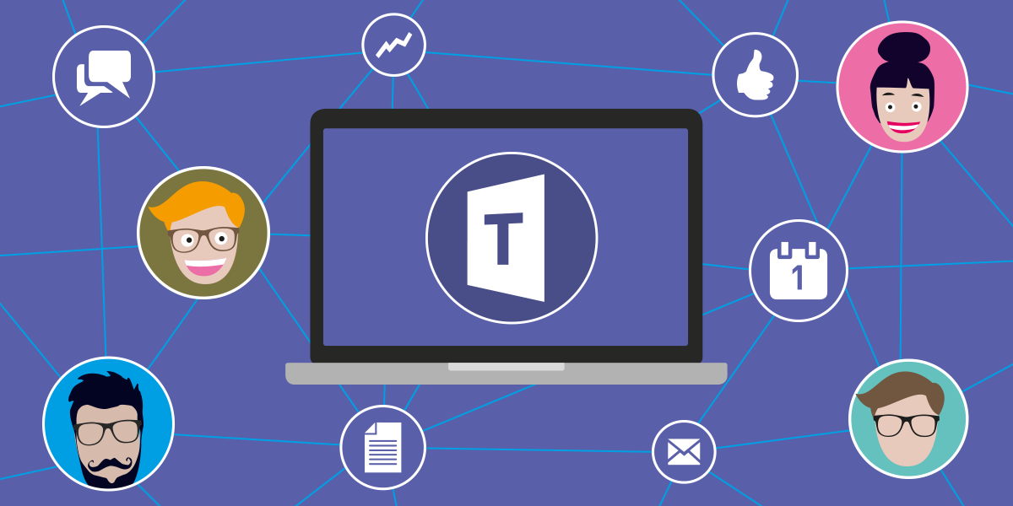Features

* Microsoft 365 integration
* Real-time collaboration
* Messaging chat
* Calling
* Video meetings
* End-to-end encryption
* Cross-device
* Free of cost
* Screen sharing